NAME:VENKATRAMAMOORTHY.G
Task 1:
a. Check if a number is positive or negative.
CODE:
<!doctype html>
<html lang="en">
<head>
<meta charset="UTF-8" />
<meta name="viewport" content="width=device-width, initial-scale=1.0" />
<title>Document</title>
</head>
<body>
<label>Enter a number: </label>
<input type="text" id="num1" /><span id="text1" hidden
>you not entered number</span
><br />
<button onclick="checksum()">check the number</button>
<div id="output"></div>
<script>
function checksum() {
document.getElementById("text1").hidden = true;
let num = document.getElementById("num1").value;
console.log(num);
if (num !== "") {
if(num===0){
document.getElementById('output').innerHTML="<p>zero</p>";
}
else if(num<0){
document.getElementById('output').innerHTML="<p>negative</p>";
}
else{
document.getElementById('output').innerHTML="<p>postive</p>";
}
} else {
document.getElementById('text1').hidden=false;
}
}
</script>
</body>
</html>
OUTPUT:
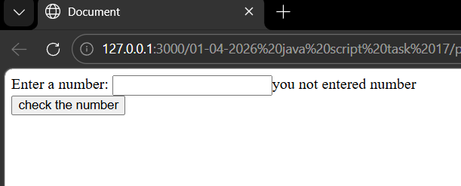
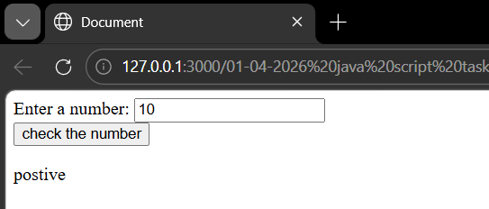
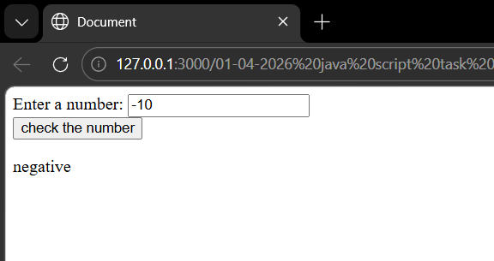
b. Create a switch to print days of the week.
CODE:
<!doctype html>
<html lang="en">
<head>
<meta charset="UTF-8" />
<meta name="viewport" content="width=device-width, initial-scale=1.0" />
<title>Document</title>
</head>
<body>
<label>Enter a number: </label>
<input type="text" id="num1" /><span id="text1" hidden
>you not entered number</span
><br />
<button onclick="checksum()">check the number</button>
<div id="output"></div>
<script>
function checksum() {
document.getElementById("text1").hidden = true;
let num = document.getElementById("num1").value;
console.log(num);
if (num !== "") {
num = Number(num);
switch (num) {
case 1:
document.getElementById("output").innerHTML = "<p>Monday</p>";
break;
case 2:
document.getElementById("output").innerHTML = "<p>Tuesday</p>";
break;
case 3:
document.getElementById("output").innerHTML = "<p>Wednesday</p>";
break;
case 4:
document.getElementById("output").innerHTML = "<p>Thursday</p>";
break;
case 5:
document.getElementById("output").innerHTML = "<p>Friday</p>";
break;
case 6:
document.getElementById("output").innerHTML = "<p>Saturday</p>";
break;
case 7:
document.getElementById("output").innerHTML = "<p>Sunday</p>";
break;
default:
document.getElementById("output").innerHTML =
"<p>Invalid day</p>";
}
} else {
document.getElementById("text1").hidden = false;
}
}
</script>
</body>
</html>
OUTPUT:
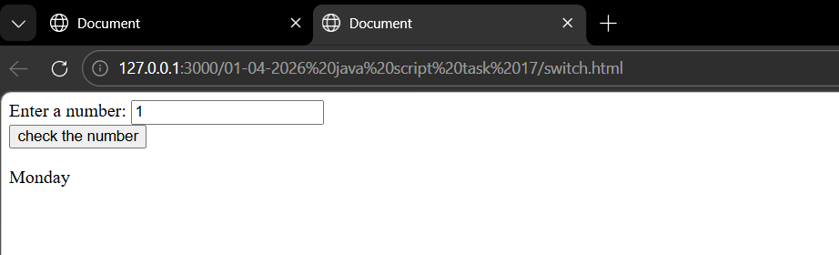
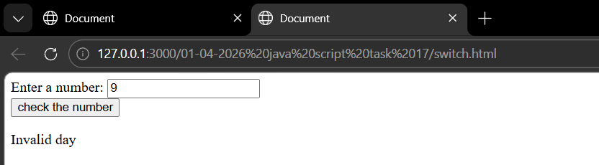
Task 2:
Story Line 1 - A Crew is travelling on a Boat. Totally 4 Members.
a. Create a list of members inside a div. Give id to both list and div.
CODE:
<!DOCTYPE html>
<html lang="en">
<head>
<meta charset="UTF-8">
<meta name="viewport" content="width=device-width, initial-scale=1.0">
<title>Document</title>
</head>
<body>
<div id="boat">
<ul id="crew">
<li><button disabled>jack sparrow</button></li>
<li>Alice</li>
<li>Bob</li>
<li>Richard</li>
</ul>
<button onclick="direction('jack')">asking jack</button>
<button onclick="direction('alice')">asking alice</button>
<div><h2>route is <span id="output"></span></h2></div>
</div>
<script>
function direction(name){
if(name==="jack"){
let say=name+' directing to north';
document.getElementById('output').innerText=say;
}
else{
let say=name+' directing to south';
document.getElementById('output').innerText=say;
}
}
</script>
</body>
</html>
OUTPUT:
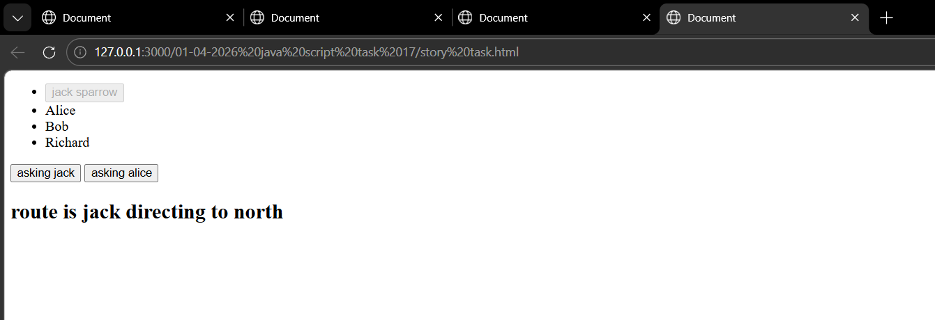
Story Line 2 - Asking route to both Jack and Alice
b. On clicking Jack button, display the route said by Jack.
c. On clicking Alice button, display the route said by Alice
CODE:
<!DOCTYPE html>
<html lang="en">
<head>
<meta charset="UTF-8">
<meta name="viewport" content="width=device-width, initial-scale=1.0">
<title>Document</title>
</head>
<body>
<div id="boat">
<ul id="crew">
<li><button disabled>jack sparrow</button></li>
<li>Alice</li>
<li>Bob</li>
<li>Richard</li>
</ul>
<button onclick="direction('jack')">asking jack</button>
<button onclick="direction('alice')">asking alice</button>
<div><h2>route is <span id="output"></span></h2></div>
</div>
<script>
function direction(name){
if(name==="jack"){
let say=name+' directing to north';
document.getElementById('output').innerText=say;
}
else{
let say=name+' directing to south';
document.getElementById('output').innerText=say;
}
}
</script>
</body>
</html>
OUTPUT:
